**Project Image Denoising**

**Introduction**

The project focuses on leveraging deep learning techniques, specifically convolutional neural networks (CNNs), to address the problem of image denoising. Image denoising is crucial in various fields such as medical imaging, surveillance, and photography, where noisy images can hinder accurate analysis and interpretation.

**Objectives**

The primary objective of this project is to develop a robust model capable of effectively removing noise from images while preserving important visual details. This involves training a DnCNN model using a dataset of noisy and clean images, evaluating its performance using metrics like Peak Signal-to-Noise Ratio (PSNR), and demonstrating its application on sample images.

**Components of the Project**

1. **DnCNN Model Architecture**
   * The DnCNN architecture consists of multiple convolutional layers with batch normalization and ReLU activation functions.
   * It is designed to learn the mapping between noisy and clean images, effectively reducing noise without losing significant image details.
2. **Dataset Preparation**
   * The dataset comprises images in JPEG, JPG, and PNG formats sourced from a specified directory.
   * Images are preprocessed by resizing them to 256x256 pixels and converting them into tensors for efficient processing.
3. **Training Process**
   * The model is trained using the Adam optimizer with a learning rate of 0.001.
   * Mean Squared Error (MSE) loss is utilized as the optimization criterion to measure the difference between the denoised and original images.
   * Training occurs over multiple epochs, iterating through the dataset in batches to update model parameters based on backpropagated gradients.
4. **Evaluation Metrics**
   * **Peak Signal-to-Noise Ratio (PSNR)**: PSNR is computed to quantitatively assess the quality of denoising achieved by the model. Higher PSNR values indicate better preservation of image fidelity.
5. **Testing and Validation**
   * The trained model is tested on sample images to evaluate its performance in real-world scenarios.
   * PSNR values and visual comparisons between noisy, original, and denoised images are used to validate the effectiveness of the model.

**Results and Analysis**

* **Visual Results**: Comparative images showing the effectiveness of the DnCNN model in denoising noisy images while retaining image quality.
* **Input image**

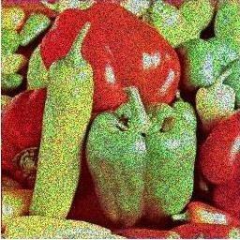

Output image

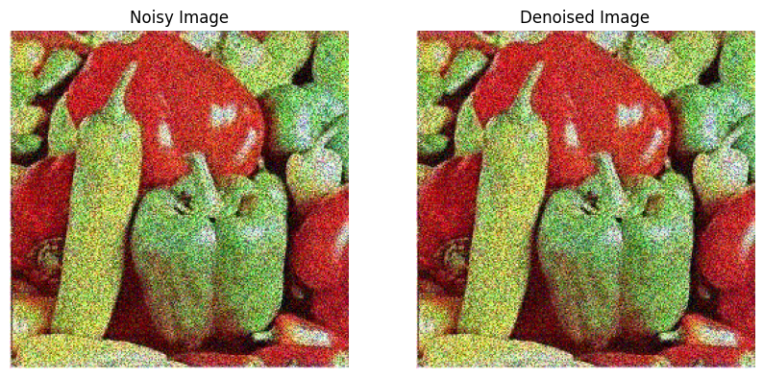

* **PSNR Analysis**: Quantitative analysis of PSNR values for test images, demonstrating the model's ability to achieve high fidelity denoising.

PSNR value is 20.57 db

**Challenges and Limitations**

* **Computational Resources**: Training deep learning models like DnCNN requires significant computational resources, particularly for processing large datasets.
* **Dataset Variability**: Variations in image quality and noise levels within the dataset can impact the model's performance and generalization capabilities.

**Future Directions**

* **Enhanced Model Architectures**: Explore advanced CNN architectures or ensemble methods to further improve denoising performance.
* **Data Augmentation**: Implement additional data augmentation techniques to enhance model robustness and generalization.
* **Real-time Applications**: Adapt the model for real-time image denoising applications, focusing on optimizing inference speed and efficiency.

**Conclusion**

In conclusion, the DnCNN project successfully demonstrates the application of deep learning in image denoising, achieving significant noise reduction while preserving image details. Despite challenges and limitations, the project lays the groundwork for future advancements in image processing and computer vision applications.

Sukhmandeep singh

22115148

Electrical engineering